**NAME:** Savan Yeshwanth Rao

**CSUID:** 2784780

**LAB-3 TCP REPORT**

1. The IP address used by client computer is- **172.20.5.19** and

the TCP port used is Source Port: **62799.**

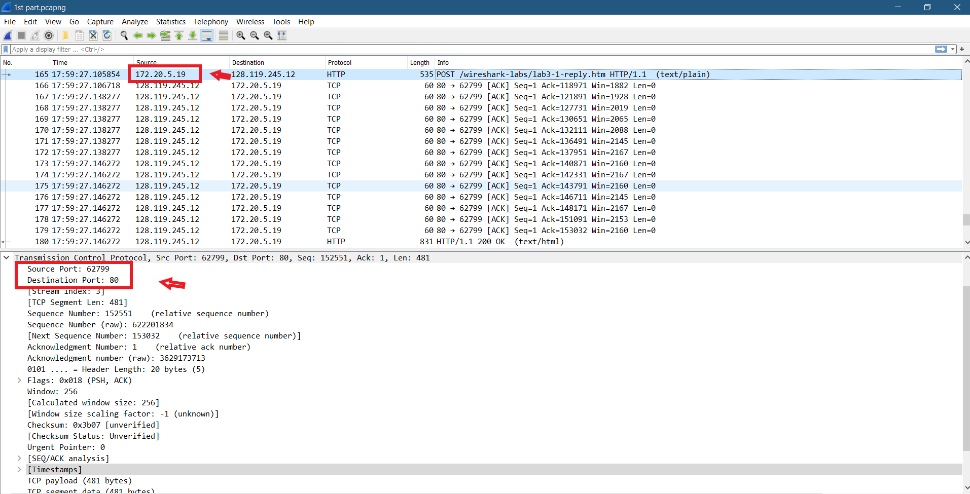

1. The IP address used by gaias.cs.umass.edu is: – **128.119.245.12**

Port number: - **80.**

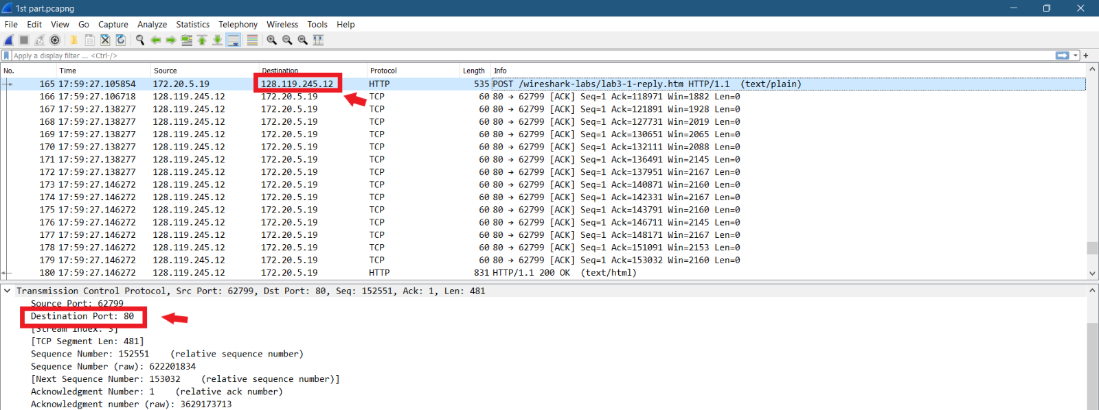

1. The answer is same as 1st as i am doing the lab in my laptop therefore,

The IP address used by client computer is- **172.20.5.19** and

the TCP port used is Source Port: **62799.**



1. The sequence number of the TCP SYN segment that is used to initiate the TCP connection between the client computer to daia.cs.umass.edu is **sequence number= 0 (zero).**

As we can see from the picture bellow that **flag is indicating it to be SYN segment**.

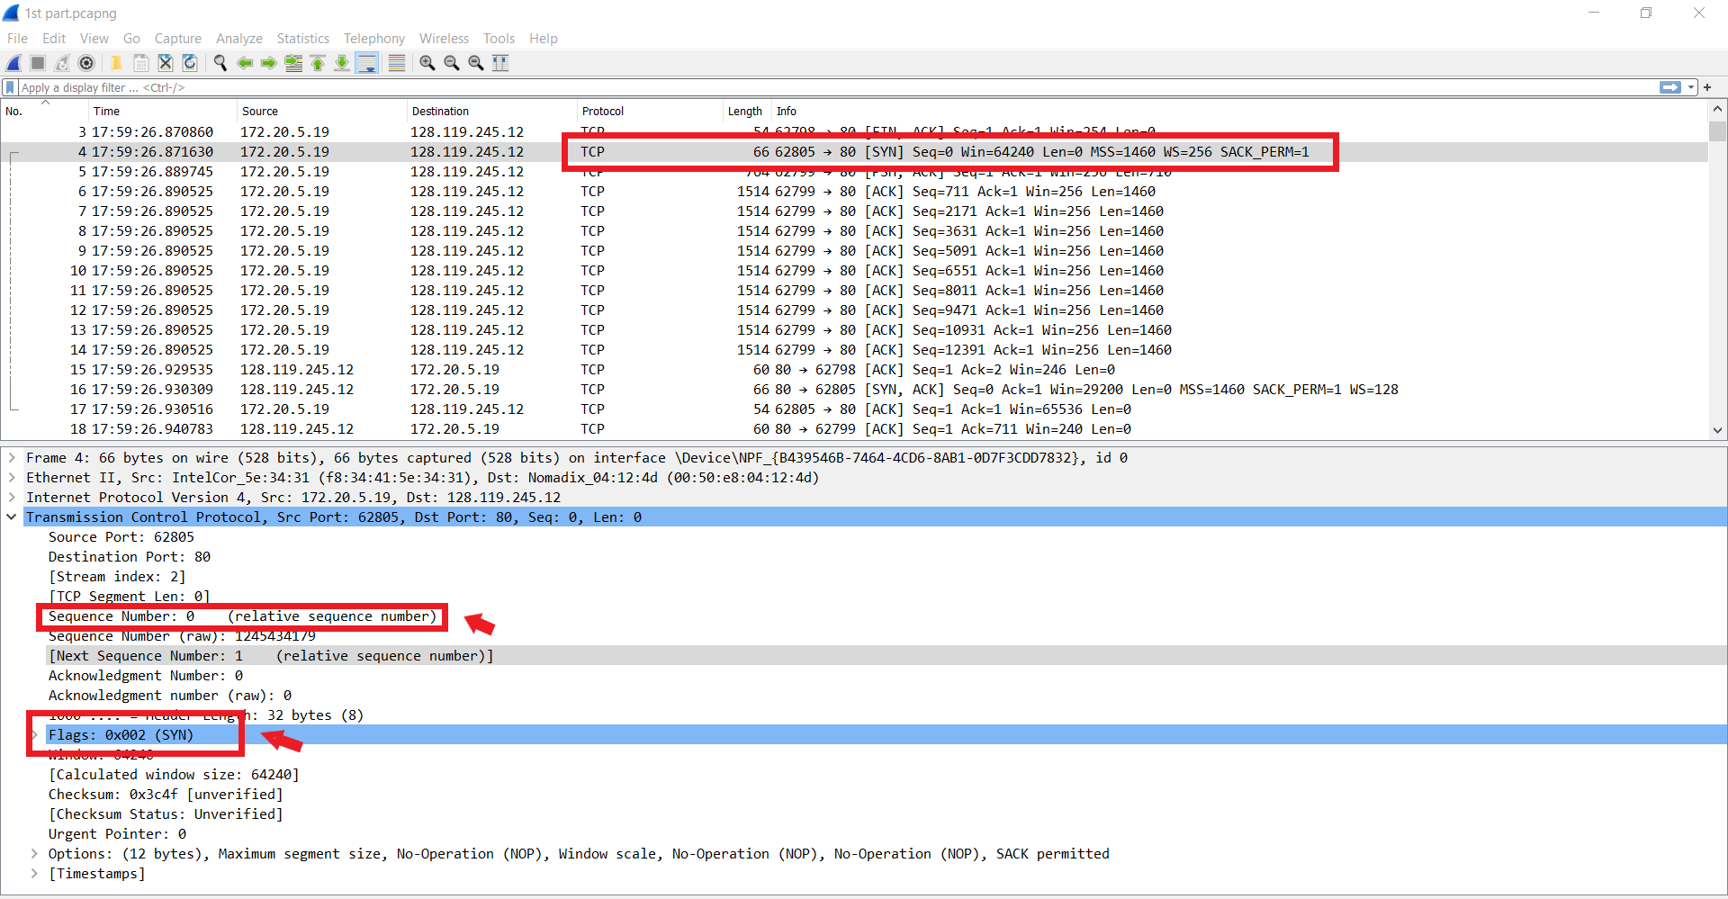

1. The sequence number of the SYNACK segment is **sequence number = 0.**

The value of Acknowledgment field in SYNACK is **ACK number = 1**.

As we can see from the screenshot bellow the message carries a flag i.e., **Flags= 0x012 (SYN,ACK) .**

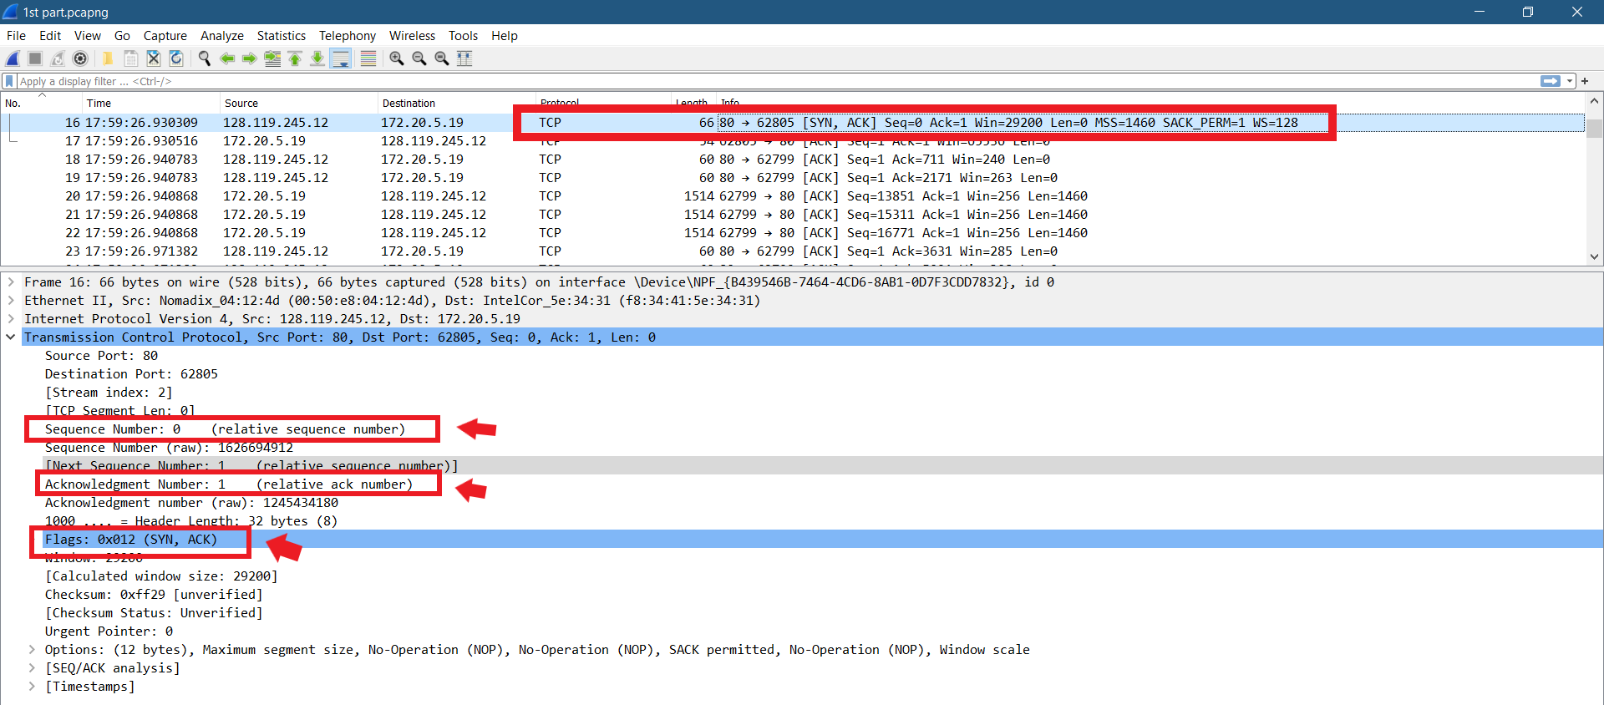

1. The sequence number of the TCP segment containing HTTP POST command is

**Sequence number = 152551**

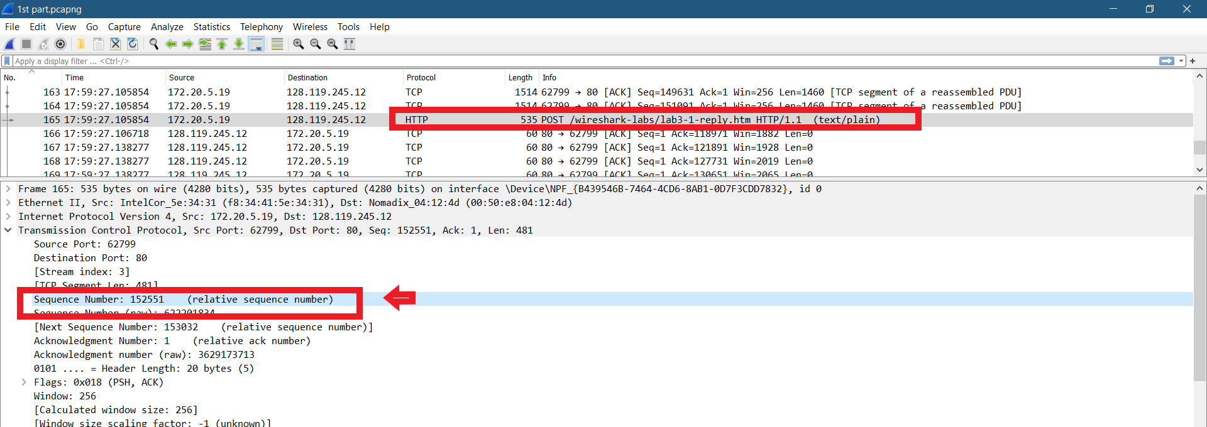

* The 1st 6 segment numbers and time for each segment sent are as follow:

1st sequence number= 1, time at= 2.032316sec

2nd sequence number= 711, time at= 2.033096sec

3rd sequence number= 2171, time at= 2.033096sec

4th sequence number= 3631, time at= 2.033096sec

5th sequence number= 5091, time at= 2.033096sec

6th sequence number= 6551, time at= 2.033096sec.

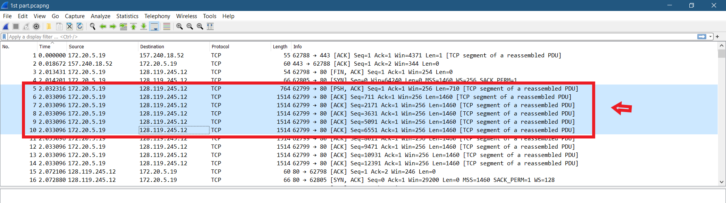

* The ACK for each segment was received at:

1st segment- no time as it is PUSH flag (PSH) PSH, ACK indicates the host is acknowledging receipt of some previous data and also transmitting some more data.

2nd segment time at= 2.083354sec

3rd segment time at= 2.083354sec

4th segment time at= 2.113953sec

5th segment time at= 2.113953sec

6th segment time at= 2.113953sec.

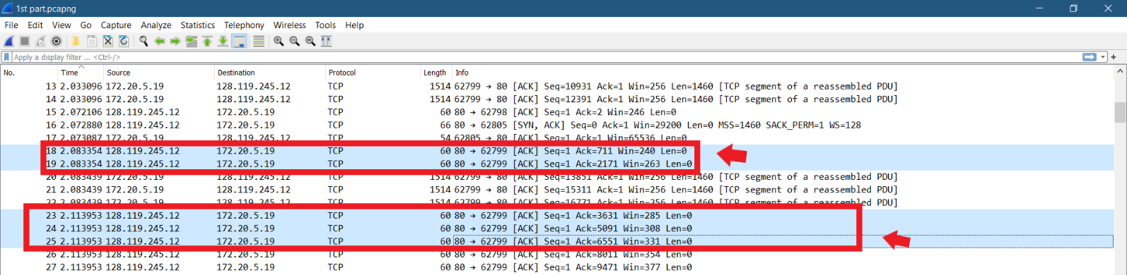

* RTT values for all:

1st segment= as it is PSH flag so no RTT.

2nd segment RTT value= 51ms

3rd segment RTT value= 50ms.

4th segment RTT value= 81ms.

5th segment RTT value= 89ms.

6th segment RTT value= 40ms.

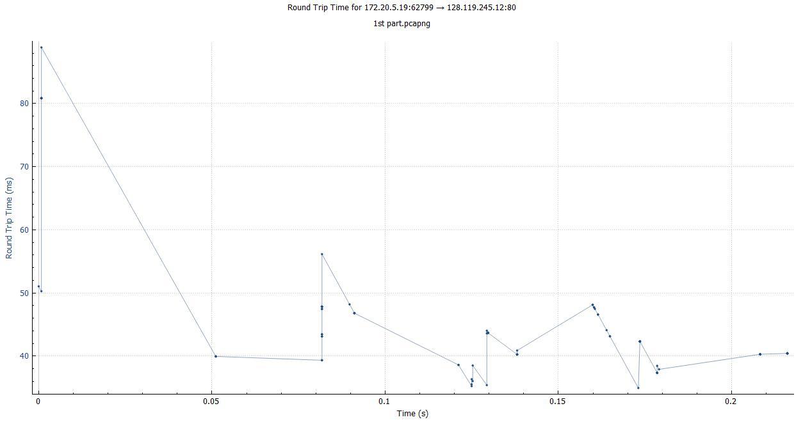

1. The length of each of the first 6 TCP segments are:

1st segment length= 710

2nd segment length= 1460

3rd segment length= 1460

4th segment length= 1460

5th segment length= 1460

6th segment length= 1460

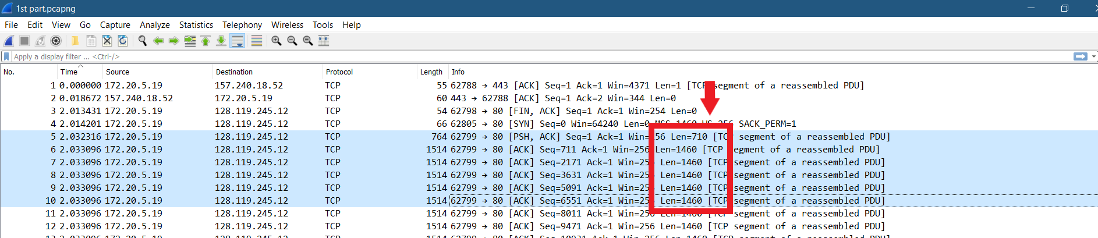

1. The minimum available amount of buffer space is **64240**.

No, the sender is never throttled because we never reach full capacity of the window.

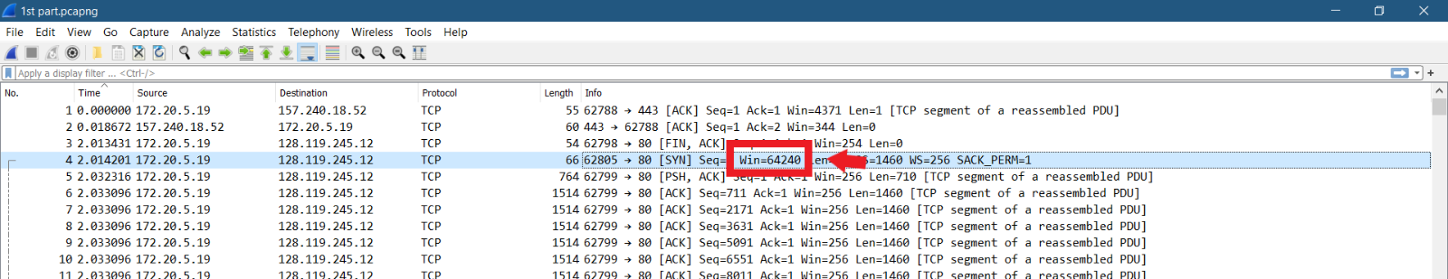

1. **No**, there are no retransmission segments in the trace file. We can check this by the **segment numbers of the packets** and also by the **TCP graph** attached bellow which shows here ar3e no packet drops and is linearly rising.

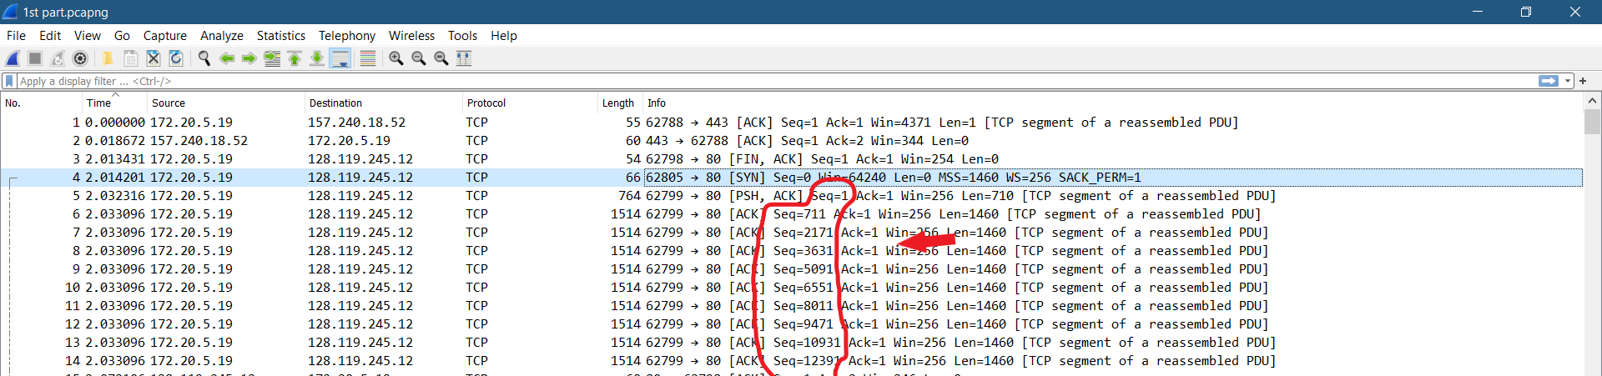

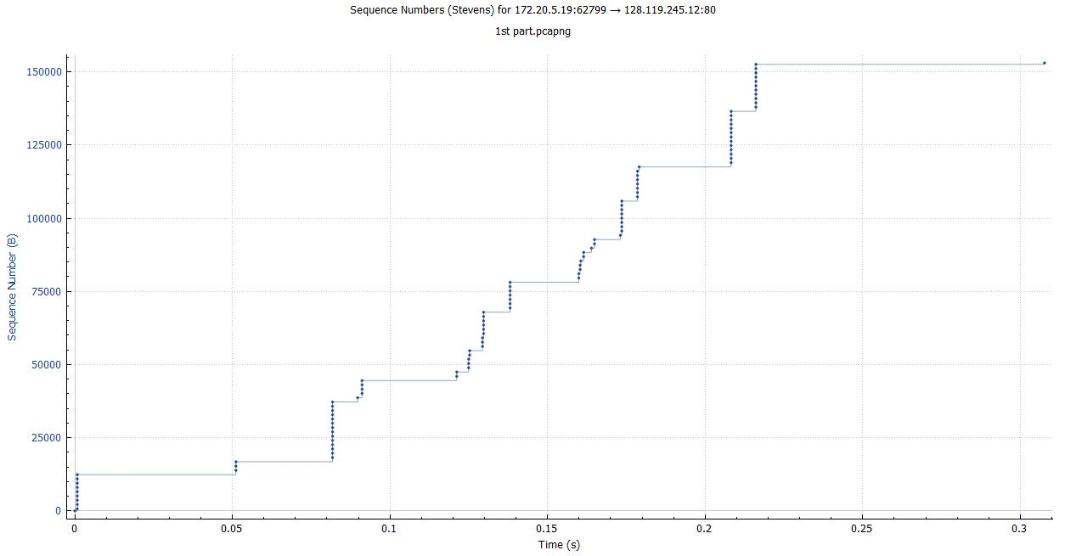

1. The ack is acknowledging usually **1460 bytes**, generally the difference between the 2 subsequent acks will give the size of the packet that was received. Example seq=711 and its length 1460 gives ack of next i.e., 711+1460=2171.

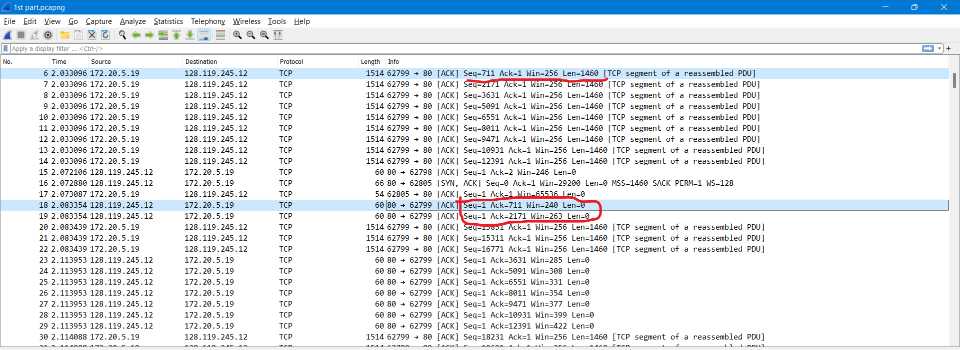

And form the screenshot bellow we can see that the receiver is Acking every other received segment.

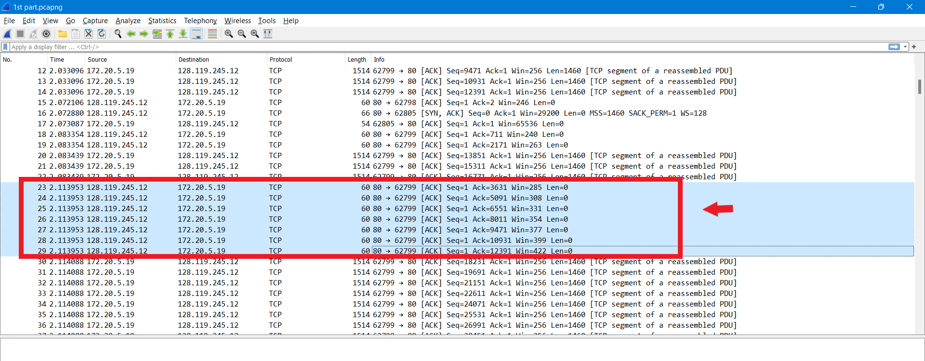

1. The throughput can be calculated by taking the total amount of data sent the time period of the connection. The total amount of data sent is 153032 and the difference between the first sequence number and the last ACK number is 153032-1 is 153031 bytes. And the total time is calculated by difference between the last ACK time and the 1st TCP packet of the message and in my case i.e., 2.288843-2.032316=0.256527. Therefore 153031/0.256527 sec = 596549 bytes/sec roughly around 597 KB/sec.

**Time sequence graph (Stevens) shown below:**



1. From my time graph the slow start is starting from zero and end at about around 0.05 seconds and later the congestion avoidance takes over at 0.17 seconds. We can see from the graph that the sender is sending mostly around 6 packets at a time so the HTTP server might have enforced a fee-restrict of some kind.
2. All the questions have been answered using my packet capture and images.